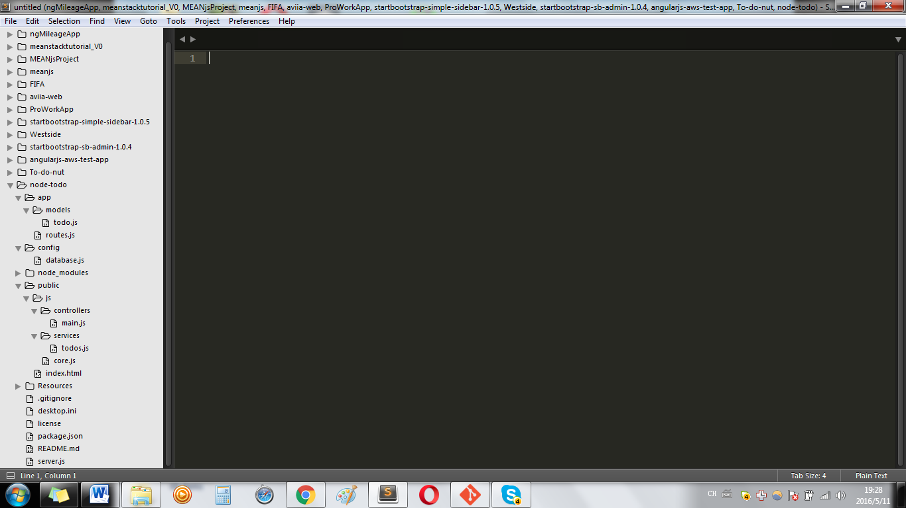

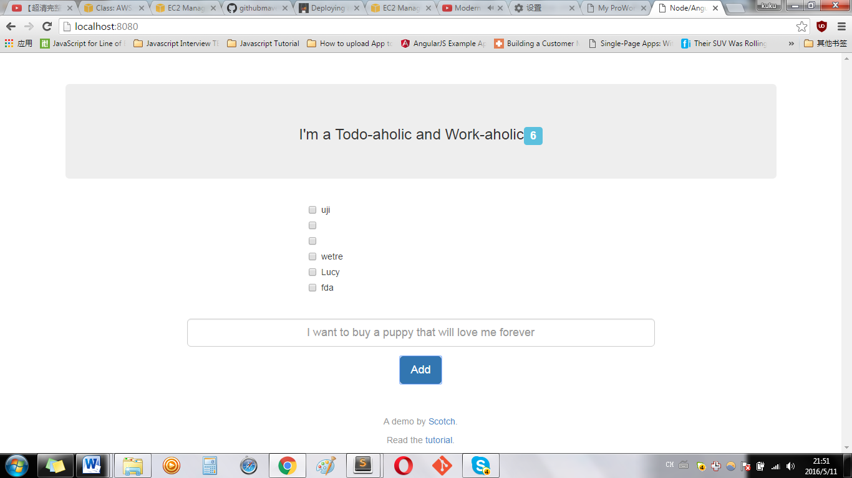

Index.html

<html ng-app="scotchTodo">

<head>

</head>

<!-- SET THE CONTROLLER -->

<body ng-controller="mainController">

<div ng-view></div>

<div class="container">

Main.js

angular.module('todoController', []) // There is no ng-app="scotchTodo"

// inject the Todo service factory into our controller

.controller('mainController', ['$scope','$http','Todos', function($scope, $http, Todos) {

$scope.formData = {};

$scope.loading = true;

ProWork

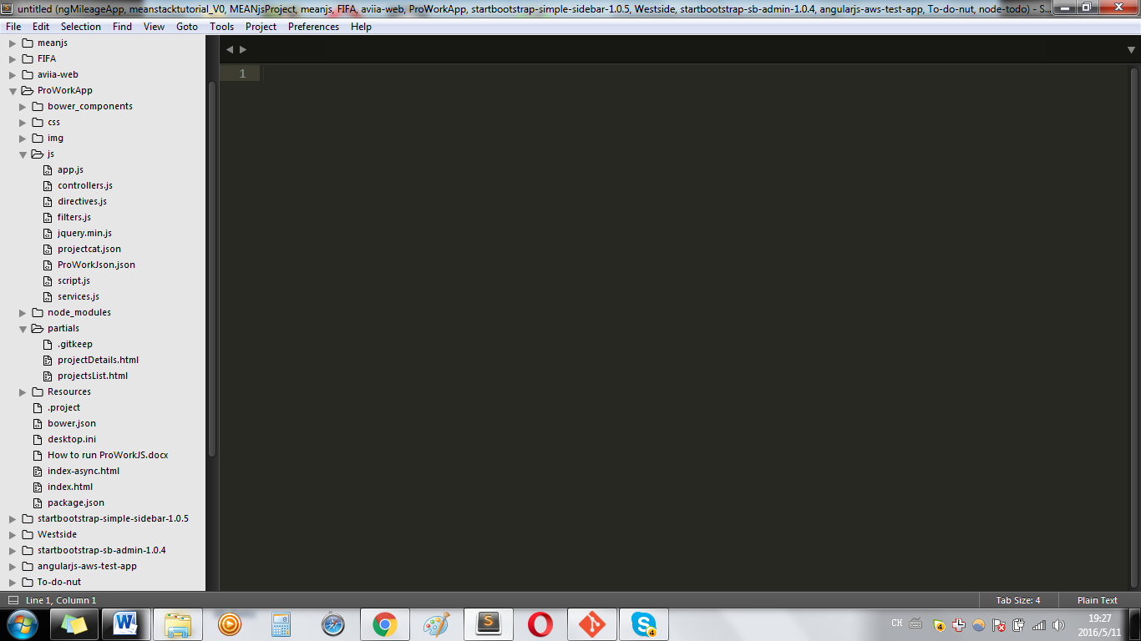

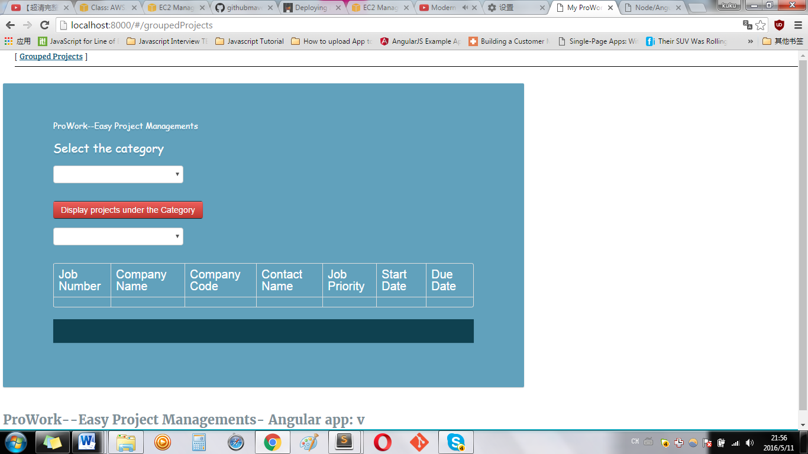

Index.html

<!DOCTYPE html>

<!--[if gt IE 8]><!--> <html lang="en" ng-app="myApp" class="no-js"> <!--<![endif]-->

<head>

<meta charset="utf-8">

</head>

<body>

<ul class="menu">

<li><a href="#/groupedProjects">Grouped Projects</a></li>

</ul>

<div ng-view></div>

App.js

angular.module('myApp', [

'ngRoute',

'myApp.filters',

'myApp.services',

'myApp.directives',

'myApp.controllers'

]).

config(['$routeProvider', function($routeProvider) {

$routeProvider.when('/groupedProjects', {templateUrl: 'partials/projectsList.html', controller: 'MyCtrl1'});

$routeProvider.when('/groupedProjects/:itemRID', {templateUrl: 'partials/projectDetails.html', controller: 'MyCtrl1'});

$routeProvider.when('/view3', {templateUrl: 'partials/partial3.html', controller: 'MyCtrl2'});

$routeProvider.when('/view4', {templateUrl: 'partials/partial4.html', controller: 'MyCtrl2'});

$routeProvider.otherwise({redirectTo: '/groupedProjects'});

}]);